FPT University
Library Management System
CM Plan

Project Code: LIB
Document Code: LIBCMP– v0.1

Ho Chi Minh City, January 31st, 2012
SIGNATURE PAGE
AUTHOR: QUANLM 31/01/2012
Team Leader – Configuration Controller

REVIEWERS: PHUNH 31/01/2012
Team Member

BAOTHQ 31/01/2012
Team Member

DIEPTN 31/01/2012
Team Member

APPROVAL: TAINT 31/01/2012
Project Manager

Record of change
*A - Added M - Modified D – Deleted
Effective Date | Changed Item | A*  M, D | Change Description | Reason for Change | Revision Number
31/01/2012 | Document | A | Create new document | Create entire CM Plan | 0.1

TABLE OF CONTENTS
1. Introduction 5
1.1. Role & Responsibility 5
1.2. Definitions and Acronyms 5
2. configuration management Process 6
2.1. CI Identification & Naming convention 6
2.2. Movement of CIs through their storage 6
2.3. Directory structure & Access right 7
2.4. Version numbering rule 9
2.5. Change control 10
2.6. Baseline plan 10
2.7. Backup strategy 11

Introduction
The purpose of this document is to identify and describe configuration management (CM) process implementing in the project LIB

Role & Responsibility
Refer to Project Organization section in Project Plan

Definitions and Acronyms

Acronym | Definition | Note
ADD | Architecture Design Document
CC | Infrastructure Configuration Controller
CI | Configuration Item
CM | Configuration Management
CSCI | Computer Software Configuration Items
DDD | Detail Design Document
PM | Project Manager
PTL | Project Technical Leader
PIC | Person in Charge
QA | Quality Assurance Officer
SRS | Software Requirement Specification
Source | Source Code
URD | User Requirement Document
TP | Test Plan
TC | Test Case
WIP | Work in Progress
WP | Work product

configuration management Process

CI Identification & Naming convention
Refer to sheet CI Identification in CM Report

Movement of CIs through their storage

For Document
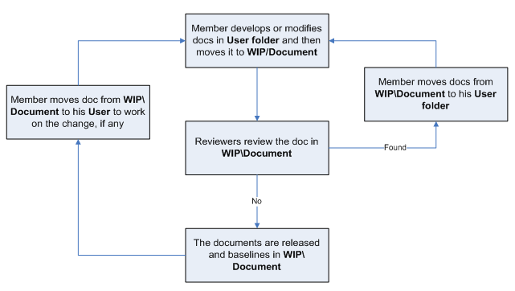

For Source code:

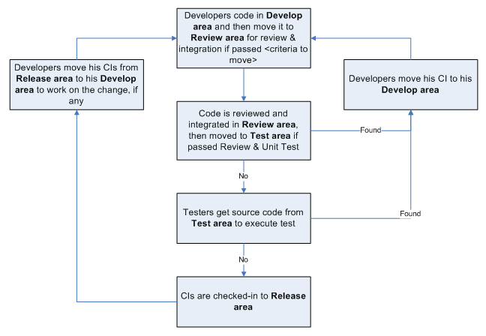

Directory structure & Access right

Promotion Areas

Area | Purpose
Develop Area | Area for different users to store his/her owned items
Review Area | To store items that is ready for review.  Reviewer get to be-reviewed items from this area
Test Area | Just applicable for Source items.  To store items passed Unit Test and Code Review
Release Area | To store the items ready for release and all released versions of items  Users get the most recent items for their usage from this area
Archive Area | To archive all released versions of each CI

Directory structure

Main Folder | Sub Folder | Purpose | Map to Area | Access right
Project Directory : https://se0425-capstone-project-lib.googlecode.com/svn/trunk/
WIP | Deliverables | Store all CIs that are delivered to customer, be possible to add date to folder name | Release | Full: PM, CC  Modify: None  Read: All
WIP | Documents | Documents of Requiements, Design, Test, … | Release + Review | Full: PM, CC  Modify: PIC  Read: All
WIP | Meeting minutes | Store project meeting minutes, including meeting minutes with customer | NA | Full: PM, CC  Modify: All
WIP | Plan | Store Proposal, Estimation, Project Plans, Project schedule, Task list | Review + Release | Full: PM, CC  Modify: PTL  Read: All
WIP | Report | Store Project Reports: Weekly , Milestone, Post-mortem, Acceptance note, other Event-driven reports | NA | Full: PM, CC  Modify: PTL  Read: All
WIP | Record | Store project records, divided into  Review: include Review, Test and Inspection records  Change request  Acceptance  Mails  ... | NA | Full: PM, CC  Modify: All
WIP | Source | Store VSS file of Source code | Archive | Refer to VSS directory
WIP | User | User’s working area, store user’s owned items | Develop | Full: PM, CC  Modify: User  Read: All
Reference | Customer supplied | store Documents and Other materials/data supplied by customer or those support software development and production operation in the project… | Release | Full: PM, CC  Modify: PIC  Read: All
Reference | Process Template | Store Guidelines/Standards/Forms/Templates/Checklist specified for the project usage | Release
Audit |  | Store QA work products  Process review  Final inspection  Work product review | NA | Full right: Project QAs  Read right: All
Archive | Baseline Name | To released versions of CIs at baselines | Archive | Full: PM, CC  Read: All
VSS Directory: N/A
N/A

For Physically stored items
Items | Location | Person in charge | Usage rule
N/A

Access right control
Access right of non-project team members (ex: auditor, external reviewer, etc) must be get permission of PM and granted in the pre-defined duration, then revoked at expiry date by CC. As soon as a member is out of the project, his or her access right is revoked also.
The access right is reviewed frequently and updated by CC at <baseline point and project closure time>.
After project asset is approved by QA at project closure time, PM informs to IT Department to revoke the access right of all project team members. If some one has a request for data reference, audit, etc, he or she must get the approval of authorized person, normally Group Leader or Division Leader, and then send the request to IT Department. IT Department is responsible for implementing such kind of requests.

Version numbering rule

For Documents:
The version level is maintained as numbered identifier with two components
1.1

Revision
Version

The original version will be numbered 0.1. Subsequent revisions will be numbered 0.2, 0.3. The release version will be 1.0.
Version number, which appears to the left of the decimal. It changes only when the core architecture of the item changes. For example: when an item is completely overhauled, with substantial internal changes, the version 1.0 would become version 2.0
Revision number, which appears to the right of the decimal. It changes when existing content is changed, but the overall structure and flow of the item remains the same. The normal sequence of revision is 1.1, 1.2 and so on.

For Software Source Files:
Software executables and support files are generally identified by name and version number, such as “Main DB v1.1.a”. The scratch edition will be 1.0. The version numbering scheme consists of three components:
1.1a

Revision

Version

Update

view

Version number, which appears to the left of the decimal. It changes only when the core architecture of the software item changes, as when moving from one area of the development tool to another, when an application is completely overhauled, or the user interface changes fundamentally. In this case, version 1.1a would become version 2.0.
Revision number, which appears to the right of the decimal. It changes when new features, functionality or other content are added or significantly changed. In normal case, the core architecture or user interface have been extended or limited in some manner. The most common reason for changing the revision number is when adding a new module or other functionality to the software. The normal sequence of revision is 1.0, 1.1, and 1.2 and so on.
Update level is appended or incremented when the only change to the software item is to correct one or more defects, without the addition of any new functionality. Version 1.1 would become v1.1a, v1.1b and so on. This updating is over ridden when a combination revision, involving bug fixes and new feature additions, is performed. In such a case, the software revision number is incremented and any update indicator is dropped, as in v1.1b to v1.2

Change control
Refer to Requirement Change Management section in Project Plan and Change Control Report sheet in CM Report.

Baseline plan

No. | Baseline Name | When Baselined | PIC
1 | Project Plan | After finishing Introduction
2 | Startup & Construction | Within 4 days
3 | Software Requirement Specification | After finishing Project plan
4 | Startup & Construction | Within 4 days
5 | Software Design Description | After finishing Software Requirement Specification
6 | Startup & Construction | Within 4 days
7 | Software Test Documentation  Guide Implementation | After finishing Software Design Description
8 | Unit Test Plan | Within 3 days
9 | Coding | Within 30 days from Unit Test Plan
10 | Review Code | Within 3 days from Coding
11 | Fix bugs | Within 11 days from Review Code
12 | Perform Integration | Within 5 days from Fix bugs
13 | System Test | Within 5 days from Perform Integration
14 | Deployment | After Software Test Documentation Guide Implementation
15 | User manual | Within 2 days
16 | Release note | Within 2 days from user manual
17 | Review and Acceptant Test | Within 4 days Release note
18 | Complete Construction and Transition Stage | After finishing Deployment
19 | Survey Customer Satisfaction | Within 1 day

Backup strategy
Storage Area to be Backed up | Items to be Backed up | Backup To | Backup Type | Backup Frequency | PIC
https://se0425-capstone-project-lib.googlecode.com/svn/trunk/ | All | https://se0425-capstone-project-lib.googlecode.com/svn/trunk/Backup | Full backup | Once a week | TL – CM

